|  |  |  |
| --- | --- | --- |
| SCHOOL OF INFORMATION AND TECHNOLOGY | | |
| NAME: FLEX D. PEDRO & AILEEN M. PUCAY | DATE PERFORMED:4-12-24 | /50 |
| Section:IDC1 | DATE SUBMITTED: 4-12-24 |

**Part 2. Network Scalability Analysis**

Recall the e-commerce website scenario we discussed earlier. Given the expected surge in traffic, analyze the provided network topology diagram. Identify potential bottlenecks and areas where scalability might be a concern. Propose specific strategies to improve the network's scalability and performance to ensure a seamless user experience during the peak traffic period. Consider factors such as increased user demand, new applications, and security threats.



|  |  |  |  |
| --- | --- | --- | --- |
| Criteria | Excellent | 10pts | Good | 7pts | Needs Improvement | 4pts |
| **Network Analysis** | Accurately identifies potential bottlenecks, security risks, and capacity limitations. | Identifies key network components and some potential bottlenecks. | Identifies some basic network components but lacks a comprehensive analysis. |
| **Scalability Planning** | Proposes multiple relevant solutions and provides detailed explanations, including potential drawbacks and benefits. | Proposes some relevant scalability strategies but lacks detail. | Proposes limited scalability strategies. |
| **Evaluation of Solutions** | Proposes comprehensive scalability strategies, including specific recommendations for hardware upgrades, software configurations, and network optimizations. | Provides a basic evaluation of the proposed solutions, but lacks depth. | Does not evaluate the proposed solutions or provides a superficial evaluation. |
| **Proposed Design** | Provides a detailed and well-justified design, including network diagrams, configuration details, and implementation plans. | Provides a basic design but lacks specific details and justifications. | Does not provide a clear and detailed design. |
| **Evaluation and Justification** | Provides a thorough evaluation of the proposed solutions, considering factors like cost, complexity, and potential impact. | Provides a basic evaluation of the proposed solutions, but lacks depth. | Does not evaluate the proposed solutions or provides a superficial evaluation |
| Score: | | | /50 |

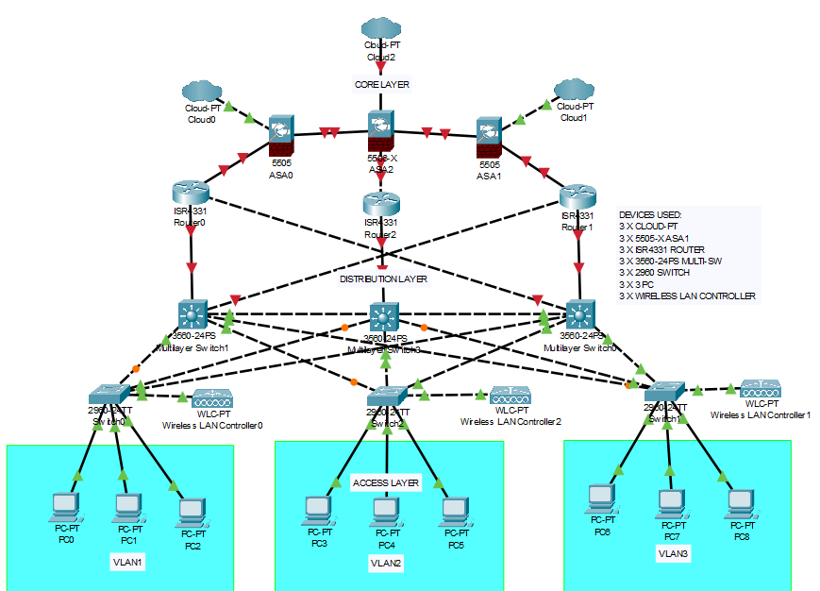

*FIGURE 1*

***Devices Used:***

DEVICES USED:

3 X CLOUD-PT

3 X 5505-X ASA1

3 X ISR4331 ROUTER

3 X 3560-24PS MULTI-SW

3 X 2960 SWITCH

3 X 3 PC

3 X WIRELESS LAN CONTROLLER

*The***access layer***provides connectivity for the users. The***distribution layer***is used to forward traffic from one local network to another. Finally, the***core layer***represents a high-speed backbone layer between dispersed networks. User traffic is initiated at the access layer and passes through the other layers if the functionality of those layers is required.*

**Enhancing Network Scalability and Performance**

The hierarchical design model significantly improves a network's scalability and performance, ensuring a seamless user experience during peak traffic periods, particularly as user demand increases, new applications are introduced, and security threats evolve.

**Scalability**

Layered Architecture: Each layer (access, distribution, core) can be scaled independently. Additional switches can be added to the access layer to accommodate more users without affecting other layers.

Load Balancing: The distribution layer can distribute traffic evenly, preventing bottlenecks and allowing the network to handle more simultaneous users.

Resource Allocation: Upgrading high-capacity routers and switches in the core layer ensures that the network can support growing demands efficiently.

**Performance**

Efficient Traffic Management: The distribution layer routes data intelligently and applies quality of service (QoS) policies, prioritizing critical applications even under heavy load.

Reduced Latency: High-speed connections in the core layer minimize latency, which is vital for real-time applications like video conferencing.

Application Support: New applications can be integrated without overloading the existing infrastructure, maintaining responsiveness for users.

**Addressing Security Threats**

Segmentation: Layer separation allows for targeted security measures, protecting against potential threats at each layer.

Policy Enforcement: The distribution layer can enforce security policies to manage data flow and contain breaches effectively.

**Implementing Wireless Connectivity**

The network must be designed to be able to expand network access to individuals and devices, as needed. An increasingly important aspect of extending access layer connectivity is through wireless connectivity. Providing wireless connectivity offers many advantages, such as increased flexibility, reduced costs, and the ability to grow and adapt to changing network and business requirements.